PRIMARY THREE LITERACY LESSON NOTES

2019

**WEEK ONE: Reporting of pupils and marking of holiday package.**

**WEEK: 2**

**THEME 1: OUR SUB-COUNTY/ DIVISION**

SUB-THEME: Name and location of our sub-county.

Aspect 1: Our school.

Our school is called Vision for Africa primary school.

It is found in -Mukono district.

-Kyampisi sub-county.

-Kyabakadde parish

-at Kiyunga village.

Aspect 2: important places in our sub-county

Some important places in our sub-county include:

* churches - schools
* hospitals - mosques
* Sub-county headquarters

Exercise

1. What is the name of our sub-county?
2. Identify two important places in our sub-county.
3. Write the name of our district.
4. \_\_\_\_\_\_\_\_\_\_\_\_\_\_\_ is the name of our parish
5. Name any four schools in our sub-county
6. Name the main hospital in our sub-county

Aspect 3: Maps and pictures

**1. What is a picture?**

A picture is a drawing of an object as seen from aside.

A picture is a representation of an object as seen from a side.

2. Examples of pictures include the following:

|  |  |
| --- | --- |
| https://encrypted-tbn1.gstatic.com/images?q=tbn:ANd9GcT_MP0yrUnuBhC9S2ZhOGPJg___X0zJZ-oud1RHIrh_M4-9OJos | https://encrypted-tbn2.gstatic.com/images?q=tbn:ANd9GcQcKHgOyl_leIrsEZzeRf4r8_W1ykFRaH67MgiXazO35ACHkSlSpw |
| A picture of a tree | A picture of a house |
| http://3.bp.blogspot.com/_hFX1PyMrRco/TPpcufYDUcI/AAAAAAAAASE/ogZJyk8gtdU/s1600/buygreen-knu-round-dining-table.jpg | https://encrypted-tbn1.gstatic.com/images?q=tbn:ANd9GcQqab5gjHsq0iRcz75cYuryKpqzyNKiptcEEv02p028tT2NoxKGvQ |
| A picture of a table | A picture of a car |

Exercise

1. What do we call the drawing of an object as seen from aside?
2. Draw a picture of a pot and a chair.

Aspect 4: A map

**What is a map?**

A map is a drawing of an object as seen above.

A map is representation of an object as seen from above.

Examples of maps:

|  |  |
| --- | --- |
|  |  |
| A map of a house | A map of a tree |
|  |  |
| A map of a table | A map of a pot |
|  |  |
| A map of a basket | A map of a hut |

3. Similarities between a map and a picture

Both are drawings of objects.

Both represent real objects.

4. Differences between a map and a picture

A map is drawn as seen from above while a picture is drawn as seen from above.

A picture is more detailed than a map.

Exercise

How is a map similar to a picture?

State one difference between a picture and a map.

Aspect 5: MAP READING

1. Maps help us to show different places.
2. Maps can be of:
3. Our school
4. Our home
5. Our village
6. Our sub county
7. Our district
8. Our country etc

Elements of a good map

A good map should have the following qualities;

1. A key
2. A heading / title
3. A compass rose/ compass direction
4. A scale
5. A frame/boundary.

Importance of each element to a map reader

(a) Heading / title;

* Shows what the map is all about.
* Without a title, a map reader will not know what the map is all about.

(b)Compass rose;

* Shows direction of places on a map.
* Without a compass rose, a map reader will not be able to tell the direction of places on a map.

(c)Frame;

* This beautifies the map.

(d)A scale;

* Shows the distance of places on a map.
* It is used to measure or calculate the distance between places on a map.

(e)A key;

* It is used to interpret symbols and colours used on a map.
* Without a key, a map reader will not be able to interpret symbols and colours used on a map.

Exercise

1. Of what use is a compass rose to a map reader?
2. Identify any other four elements of a good map.
3. Which map element interprets map symbols?

Aspect 6: DIRECTION

* What is direction?

Direction is a position in which a person is standing, moving or facing.

* We can tell direction of places using an instrument called a compass.

A compass rose is an element of a map that shows direction of places on a map.

* A compass has got points which show directions.

A compass has four major (primary) points called cardinal points namely;

* North(N)
* South(S)
* East(E)
* West.(W)

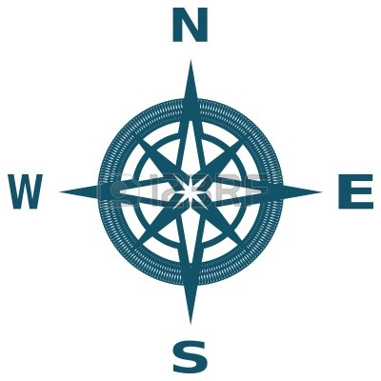

Exercise

1. How is the use of a compass similar to that of a compass rose?
2. What general name is given to the four major points of a compass?

3. How is a compass different from a compass rose?

2. A compass needle rests in the magnetic North.

3. The sun rises from the East and sets in the West.

4. People who use a compass to do their daily work

* rally drivers
* captains
* sailors
* tourists
* scouts and guides
* soldiers
* mountain climbers

Aspect 7: Our sub-county and its neighbours.

The name of our division is Kyampisi.

Kyampisi is one of the ---- divisions of Mukono district.

It is found in the -------.

Important places in our sub-county include.

Sub-county headquarters, churches, hospitals, mosques, schools, etc.

**Neighbours of our division include**;

1. The North:
2. The West:
3. The South:
4. The East:

5. Other ways of telling directions without using a compass include the following:-

* Using the sun
* Using shadows

6. A shadow is shortest at noon (midday) and longest in the morning and evening.

Exercise

1. Name any two semi- cardinal points.
2. In which direction does the sun set?
3. Mention any two groups of people who need a compass in their work

Aspect 8: SYMBOLS ON A MAP

1. What are map symbols?

Map symbols are small drawings used on a map to stand for real objects or features.

**2. Reasons why symbols are used on maps**

They avoid overcrowding on a map.

They represent real objects on a map.

**3. Examples of map symbols**

|  |  |
| --- | --- |
|  |  |
| A symbol of a hill | A symbol of a lake |
|  |  |
| A symbol of a dam | A symbol of river |
|  |  |
| A symbol of a swamp | A symbol of a forest |
|  |  |
| A symbol of a water fall | A symbol of quarry |
|  |  |
| A symbol of a railway line | A symbol of a mountain |
|  |  |
| A symbol of mountain peak | A symbol of a factory |
|  |  |
| A symbol of a church | A symbol of an airport |
|  |  |
| A symbol of a bridge | A symbol of a plateau |
|  |  |
| A symbol of a bridge | A symbol of a school |

Exercise

1. What do we call the small drawings that stand for features on a map?
2. Why are symbols used on a map?
3. Draw and name any two map symbols you know.

**TOPICAL TEST**

1. What is the difference between map and a picture?

2. Mention two elements of a good map.

3. How is a key useful to a map reader?

4. What are map symbols?

5. Why are symbols used on a map?

6. Draw the map symbols for the following features.

a) A dam

b) A forest

c) A quarry

7. Name the instrument used by a pilot to detect direction of places.

8. From which direction does the sun rise?

9. What general name is given to the four major points of a compass?

10 What problem will Richard face in reading a map without a compass rose?

**WEEK 3**

**THEME 1: OUR SUB-COUNTY/ DIVISION**

**SUBTHEME 2: PHYSICAL FEATURES IN OUR DIVISION**

ASPECT 8: EXAMPLES OF PHYSICAL FEATURES.

* 1. What are physical features?

These are natural landforms that give land shape

Physical features are also called **landforms.**

2. What are landforms?

Landforms are natural features that give land shape.

3. **Examples of physical features include the following:-**

* *hills*
* mountains
* valleys
* plains
* lakes
* streams
* rivers
* islands
* oceans
* seas
* water falls
* rift valleys

4. **Examples of physical features found in our division**:

* Hills
* Valleys

**Exercise**

1. What do we call the natural landforms in an area?

2. Name any three landforms.

3. What physical feature is surrounded by water?

ASPECT 9: LAKES AND RIVERS

1. What is a lake?

A lake is a large water body in a basin.

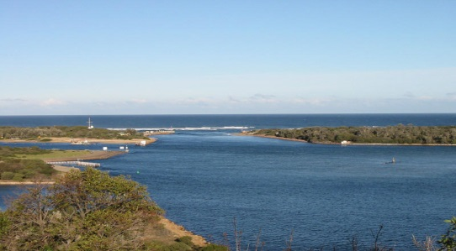

1. Examples of lakes in Kampala include the following:-
   * Lake Victoria (Natural-lake)
   * Kabaka’s lake (human-made lake)
2. What is a river?

A river is a narrow and long flowing water body.

[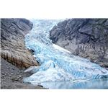](http://img.bhs4.com/be/c/beca0a9d38c70692dfb386eff558ad1b6a9627a2_large.jpg)

4. Rivers flow from a higher level to a lower level.

NB: There are no rivers in our division.

**Importance of lakes and rivers to people**

* They are used for water transport**.**
* People get clay, stones and sand used for building.
* Lakes and rivers provide fish and water to people.
* Rivers help in generating hydro electricity.
* They attract tourists.
* Lakes help in formation of rainfall.

**Exercise**

1. Name the man-made lake is found in Kampala district.

2. Which water body flows from a high level to a low level?

3. Why do some people like staying near lakes and rivers?

ASPECT 9: PLATEAU

1. What is a plateau?

A plateau is a raised flat topped piece of land.

A plateau is a table land

**2. Importance of the plateau to people**

* People build houses on the plateau.
* People grow crops on the plateau.
* People graze animals on the plateau.
* Roads, railways and airports are built on plateaus.

ASPECT 10:HILLS

1. What is hill?

A hill is a slightly raised piece of land.

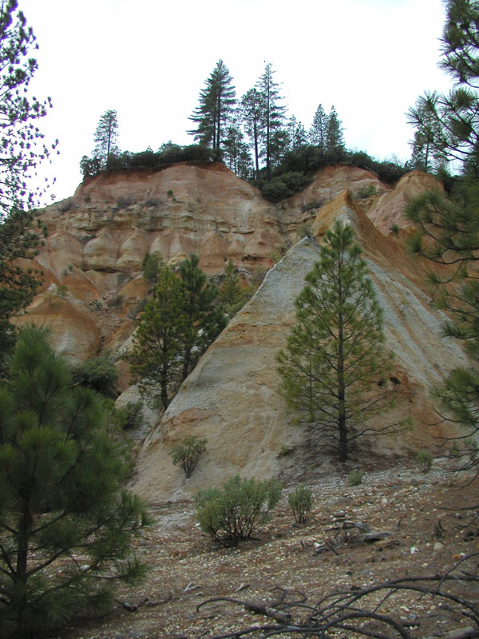

1. **Importance of hills to people**

* People settle on hills.
* They grow crops on hill slopes
* People graze their animals on hills
* Hills help in the formation of rainfall.
* People build masts on hills.

ASPECT 11: VALLEYS

1. What is a valley?

A valley is lowland between two or more hills or mountains.

**2. A picture of a valley**

|  |
| --- |
| valley  Mountain/  hill |

**4. Importance of valleys to people:**

* People get water from valleys.
* Valleys are used for growing crops.
* People settle in valleys.

5. **Why is it not good for people to settle in valleys?**

* They flood during the wet season.
* Valleys are breeding places for vectors like mosquitoes.
* There is poor communication network.
* There are landslides in valleys.

Effects of physical features

* Mountains and valleys make transport and communication difficult.
* Bad people and animals hide in valleys and harm others.

Human activities done around specific physical features

* Fishing around lakes and rivers
* Quarrying around mountains
* Pottery and brick making around swamps
* Farming in plains, plateaus and valleys

Exercise

1. Define a valley.
2. Name any two valleys in Kampala.
3. Write two problems faced by people staying in valleys.

**TOPICAL TEST**

1. What are physical features?
2. Identify any two landforms that are in Kyampisi sub-county.
3. State any two uses of each of these physical features.
4. Lakes and rivers
5. Hills and plateaus
6. Valleys
7. What term is used to mean each of the following?
8. A raised flat-topped area.
9. A lowland between two or more hills or mountains
10. Mention any two dangers of physical features

**WEEK 4**

**THEME 1: OUR SUB-COUNTY/ DIVISION**

**SUB-THEME 3: PEOPLE IN OUR SUB-COUNTY**

ASPECT 12: ETHNIC GROUPS, TRIBES AND CLANS

* 1. **What is an ethnic group?**

An ethnic group is a group of people with the same origin speaking related languages.

-An ethnic group is also called **a tribal group**.

2. **What is a tribe**?

A tribe is a group of people with the same origin, customs and language.

3. **What is a clan**?

A clan is a group of people under one fore -father. (ancestor)

An ancestor is a person who lived long ago in a family.

**4. Examples of ethnic groups and their origins in our division**

* Bantu
* Nilotics
* Nilo-hamites
* Hamites

**Bantu** is the largest ethnic group in our division

**Exercise**

1. What is a tribal group?
2. What do we call a group of people under one forefather?
3. Name the biggest ethnic group in Kyampisi sub-county?
4. To which ethnic group do you belong?

ASPECT 13: TRIBES AND THEIR LANGUAGES.

**Tribes and languages in each ethnic group;**

|  |  |  |
| --- | --- | --- |
| **Ethnic group** | **Tribe** | **Language** |
| 1.Bantu | Baganda  Basoga,  Banyankore  Bakiga,  Banyoro  Batoro,  Bagisu,  Bagwere,  Basamia  Baruuli. | Luganda  Lusoga  Runyankore  Rukiga  Runyoro  Rutoro  Lugisu  Lugwere  Samia  Ruruuli |
| 2. Nilo-Hamites | Karimojong  Iteso  Sabiny.  Kumam  Langi | Akarimojong  Ateso  Kupsabiny  Kumam  Langi |
| 3.Nilotics | Acholi  Lugbara  Jaluo  Japadhola | Acholi  Lugbara  Luo  Adhola |
| 4. Hamites | Bahima  Batutsi  Bahororo | Runyankore  Kinyarwanda  Runyankore |

Examples of clans among Baganda.

Ngabi clan Ngeye clan Nyonyi nyane clan Nvubu clan

Mmamba clan Nte clan Kayozi clan Njaza clan

**Exercise**

1. What is your tribe?
2. Name two Bantu tribes you know.
3. Which language is spoken by the Acholi?

**TOPICAL TEST**

1. What term is used to mean each of the following?
2. A group of people of the same origin speaking related languages.
3. A group of people of the same language and customs.
4. A group of people living together related by blood or marriage.
5. Identify four ethnic groups in Kyampisi sub-county.
6. Under which ethnic group do the Karimojong belong?
7. Give any three Bantu tribes in Kampala district.
8. Which language is spoken by each of these tribes?
9. The Baganda
10. The Iteso
11. Name the largest ethnic group in our sub-county.
12. How are the Basoga and Banyankole similar?

WEEK 5

ASPECT14: LEADERS IN SUB-COUNTY

1. Who is a leader?

A leader is a person who guides and manages others.

**Duties of a leader**

* Encourages others to work hard.
* Supervises others
* Teaches others their responsibilities.
* Settles disputes
* Maintains peace.

**Types of leaders in our sub**-**county**

1. Religious leaders
2. Political leaders
3. Cultural leaders
4. Civic leaders

**1. Examples of religious leaders include the following.**

Pastors Priests Sheikhs Evangelists Bishops Imams

Reverend

**2. The roles of religious leaders**

* They teach people the word of God.
* The guide and counsel us.
* They help the needy people like; orphans, widows and the blind

**Exercise**

1. Who is a leader?
2. State any one role of each of these leaders.

a pastor

an Imam

1. Mention any two leaders in a church.

**1. Examples of cultural leaders**

kings

clan leaders

chiefs

2. **Tribes in Uganda and their kings**

|  |  |  |
| --- | --- | --- |
| Tribe | Title | Name |
| Baganda | Kabaka | Ronald Muwenda Mutebi |
| Ankole | Omugabe | - |
| Banyoro | Omukama | Solomon Gafabusa |
| Toro | Omukama | Oyo Nyimba Kabamba Iguru IV |
| Basoga | Kyabazinga | - |
| Iteso | Emorimor | Papa Osuban Adugala |

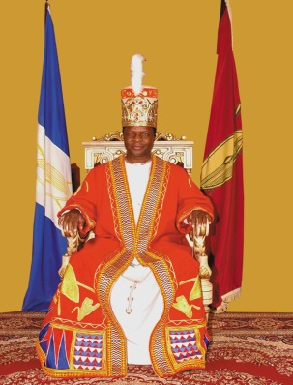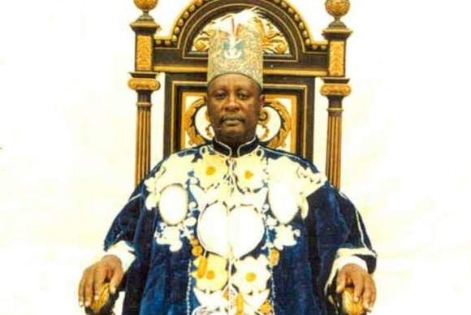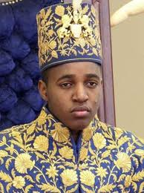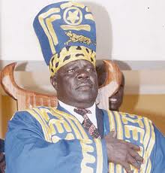

**Kabaka Ronald Omukama Solomon Omukama Oyo Papa Osuban**

**Mutebi Gafabusa Kabamba Adugala**

**Duties of cultural leaders**

* They promote culture.
* They unite people.
* They help to develop their areas.

**3. Examples of civic leaders**

DEO

CAO

DDHS

**Exercise**

Who is the current king of Buganda kingdom?

Which title is given to the king of Toro?

Which tribe is rule by an Emorimor?

State one role of a king king.

**1. Political leaders include the following**

* Local council 1
* Local council 2
* Local council 3
* Local council 4/MP
* Local council 5 Mayor

2. The local council committee is headed by **the Chairperson**.

3. The local council committee is made up of **ten** members.

**Duties of the local council**;

* To keep law and order
* To organize meetings
* To settle disputes

**Exercise**

* 1. Who is the political head of;
  2. A village?

1. A country?
2. How many members make up the LC 1 committee?
3. What is the role of the LC in an area?

**Members of local council and their responsibilities**;

1. **Chair person**;

- Chairs meetings

-Heads the local council

-Signs official documents

2. **Vice chair person;**

-Assist the chairman

-In charge of children’s affairs.

3. **The general secretary;**

-records minutes

-keeps records

4**) Secretary of finance**; -calls the executive meeting

5) Secretary for security

6) Secretary for information, education and mobilization

7) Secretary for youth and education

8) Secretary for women and public affairs

9) Secretary for the disabled.

10) Secretary for production and environmental protection

**TOPICAL TEST**

1. Identify three types of leaders in your area.
2. Mention two leaders in a church?
3. Who is the current Lord Mayor of Kampala district?
4. Write the title given to the kings of the following kingdoms.

Buganda

Ankole

1. How many members make up the LC 1 executive committee?
2. Why should a village have a Local Council?
3. Who heads the Local Council?
4. Which LC member is in-charge of the following?

Children’s affairs

Women’s affairs

Security

1. Why should we have the LC in our areas?

WEEK 6

**THEME 2: LIVILIHOOD IN OUR SUB-COUNTY/DIVISION**

**SUB-THEME 1: OCCUPATIONS OF PEOPLE IN OUR SUB-COUNTY AND THEIR IMPORTANCE.**

ASPECT: ECONOMIC ACTIVITIES

1. What is an economic activity?

An economic activity is any work done by people to get money.

2. People in our areas have different economic activities namely:

* brick making/laying
* fishing
* mining
* pottery
* nursing
* welding
* tailoring
* teaching
* hair cutting
* cattle keeping
* weaving
* carpentry
* car washing
* road construction
* building
* craft making
* farming;
* trade

3. Define these terms;

1. **Trade:** Is the buying and selling of goods.
2. **Farming :**This is the growing of crops and keeping /rearing of animals
3. **Crafts:** Are things made by hands from local materials.eg.
   * balls
   * doormats
   * ropes
   * baskets
   * necklaces

|  |  |  |
| --- | --- | --- |
| ANd9GcS_OaeiAVm3791fjQP7DbAYfRxMA7nRQRxkRTu0qRJVvLSDTeV0mQ | ANd9GcQD_eUyMfhkmyRTjm0yBWVPpHh-NuGBK6XF3wb-VdviPs_FhBxP | ANd9GcT3jefl9G1qGD_Iq1E2r_CeSXhj4Ugfdmq7hToVQnZzmKTzGINTdg |
| a doormat | a basket | a pot |

4. The main economic activity of most people in villages is **farming**.

5. The main economic activity carried out near lakes and rivers is **fishing**.

**Importance of economic activities**

* Economic activities help people to get money.
* They help people to get jobs.
* Economic activities help people to get knowledge and skills.
* Some economic activities help us to get food.

**Exercise**

1. What do we call work done by people to get money?
2. Give four examples of such activities.
3. What is the main economic activity of most people in villages.

**TOPICAL TEST**

1. What is an economic activity?
2. State any four economic activities of people in your division.
3. What is the major economic activity around lakes?
4. Write the meaning of the words
5. Farming
6. Trade
7. Crafts
8. Which other term can be used to mean economic activity?
9. Who is a farmer?
10. Name any products produced by these people.
11. A farmer
12. A tailor
13. A carpenter

**WEEK: 7**

**SUB-THEME 2: SOCIAL SERVICES IN OUR SUB-COUNTY**

**1. What are social services?**

Social services are services provided by the governmentto make people’s lives better.

**2. Examples of social services.**

* education
* health
* housing
* banking
* security
* communication services
* transport
* water supply

**EDUCATION SERVICE**

1. Education service is provided by the following people

* teachers
* lecturers
* professors
* tutors

**2. Importance of education**

* To learn how to read and write.
* To get jobs.
* To learn how to count.
* People learn how to prevent diseases.

**Exercise**

1. **What are social services?**
2. **List two social services in your area.**
3. **Why should people go to school?**

**Important officials in education service**

1. The **District Director of Education** (DDE) heads all schools in a district.

NB. All schools in Uganda are under the **Ministry of Education and Sports. (MOES)**

2. The Minister for Education and Sports is **Hon. Janet Kataha Museveni**

**Exercise**

1. **Who heads all schools in a district?**
2. **Write MOES in full.**
3. **Who is the current minister for education and sports?**

**WATER SUPPLY**

1. People who provide water services are called **plumbers.**

2. The body responsible for supplying piped water in our country is **NWSC.**

3. NWSC in full is **National Water and Sewerage Corporation.**

**SECURITY SERVICE**

1. Security means having peace in an area.

2. **People who provide security service in our sub-county include;**

* The army
* Police
* Local Defense Units(LDUs)
* Local Councils(LC)
* Private security guards

**3. How do the above organs keep security?**

1. **The army**; Fights all people who attack us with guns.

* It defends the country from external attacks like rebels.

1. **The police**; Keeps law and order.
2. **The LDUs**; Works with the police to arrest wrong doers.
3. **The prison force**; Keeps wrong doers out of good people.
4. **The LCs**; Keep law and order in communities like in villages.

4. **Why are wrong doers kept in prisons?**

* To reform (change) into good people.
* To stop them from committing more crimes.
* To separate / isolate them from good people/citizens.

**5. How do the police keep law and order?**

* By arresting wrong doers.
* By keeping wrong doers in cells before they are taken to court.
* By controlling traffic on roads.
* By investigating crimes.

**Exercise**

1. **Name any two groups of people who provide security to us.**
2. **How does the police keep law and order?**
3. **Why are wrong doers taken to prisons?**

**WEEK:8**

**TRANSPORT SERVICE**

1. **What is transport**?

Transport is the movement of people and goods from one place to another.

2. **Types of transport**

* Road transport
* Water transport
* Air transport
* Railway transport.

3**. Means used in road transport**

* cars
* lorries
* bicycles
* tricycles
* motorcycles
* buses
* omnibuses
* wheelbarrows
* animals like donkeys, horses, oxen, camels.
* walking or running

|  |  |  |
| --- | --- | --- |
|  |  |  |
| Lorry | Taxis | Buses / vans |
|  |  |  |
| cart | cars | Wheel barrow |

**Exercise**

1. **Define the term transport**
2. **Mention two types of transport used in your division**
3. **Draw, name and colour any two means of road transport**

**1. Advantages of road transport**

* It is very common.
* It is cheap to construct roads.
* It has many means of transport.

**2. Disadvantages of road transport**

* Accidents are very common.
* Roads in towns have a lot of traffic jam.
* Marrum roads are slippery in the wet season and dusty in dry seasons.

**Exercise**

1. **What is the commonest type of transport used in Makindye.**
2. **Why is road transport used by most people in your division?**
3. **State any one disadvantage of road transport.**

WATER TRANSPORT

1. **Means used in water transport**

* boats
* ships
* ferries
* sub-marines
* canoes
* yachts
* rafts

|  |  |  |
| --- | --- | --- |
|  |  |  |
| boat | ferry | ship |

**2. Advantages of water transport**

* It is the cheapest type of transport.
* It is the best type of transport for carrying bulky and fragile goods.
* It is not affected by traffic jam.

**3. Disadvantages of water transport**

* It is very slow and so it cannot be used to carry perishable goods.
* Water accidents are always fatal (deadly).
* It can be affected by bad weather.

**Exercise**

1. **Which type of transport is the best for carrying bulky goods?**
2. **Why is water transport not good for carrying perishable goods?**
3. **Draw, name and colour any two means used on water transport**

AIR TRANSPORT

**1. Means used in air transport**

* + aero planes
  + air balloons
  + rockets
  + parachutes
  + air-ship
  + helicopters

|  |  |  |  |
| --- | --- | --- | --- |
|  |  |  |  |
| Aero plane | parachute | helicopter | rocket |

2. **An aeroplane** is the fastest means of transport used in Uganda.

3. The fastest type of transport used for long distances is **Air transport.**

**4.** **Entebbe Airport** is the only international airport in Uganda.

* It is found in Wakiso district.

**Exercise**

1. **Name the fastest means of transport used for long distances?**
2. **Where do we find the international airport in Uganda?**
3. **Draw, name and colour any two means of air transport**

**1. Advantages of Air transport**

* It is the fastest type of transport.
* It is the best for carrying perishable goods.
* It is very comfortable.
* It is not affected by jam.

**2. Disadvantages of air transport**

* + It is very expensive
  + It is affected by bad weather.
  + It is not common in many places.

**Exercise**

1. **Why is air transport the best for carrying perishable goods?**
2. **Give one reason why air transport is used by few people.**

RAILWAY TRANSPORT

**1. Means used in railway transport**

* Trains

|  |
| --- |
|  |
| A train |

**2. Advantages of railway transport**

* It can be used for carrying bulky goods.
* It is cheaper than road and air.
* It’s not affected by traffic jam.

**3. Disadvantages of railway transport**

* It is very expensive to construct railway line.
* It is not common in many places.
* It is very slow.

**4. Importance of transport**

Transport is good because:-

* It helps people to move from one place to another.
* It makes trade easy.
* It helps to carry goods.

**Exercise**

1. **How is railway transport better than road transport?**
2. **Which means of transport is used on railway lines?**
3. **Why is railway transport not good for carrying perishable goods?**

**WEEK:9**

**COMMUNICATION**

1. What is communication?

Communication is the sending and receiving of messages.

**2. Means of communication**

Communication means can be grouped into traditional (local) and modern means.

1. **Traditional means of communication include**:
   * drums
   * whistles
   * horns
   * bells
   * gestures
   * smoke/fire

|  |  |  |
| --- | --- | --- |
|  | drum1 |  |
| A whistle |  | A horn |

**3. Draw and name any two local means of communication**

**Exercise**

1. **What do we call the sending and receiving of messages?**
2. **Mention two places where whistles are used for communication.**
3. **Draw, name and colour any three local means of communication.**

**1. Modern means of communication include;**

* telephones
* newspapers
* televisions
* telexes
* telegrams
* computers
* radios
* letters

|  |  |  |  |
| --- | --- | --- | --- |
|  |  |  |  |
| A television | A telephone | A radio | Newspapers |

**Exercise**

1. **Give two uses of a radio to people.**
2. **How can televisions be a problem to people?**
3. **Why are there few people who use computers?**
4. **Draw, name, and colour any two modern means of communication.**

**MEDICAL SERVICE**

1. We get medical services from.

* + hospitals
  + clinics
  + dispensaries
  + drug shops
  + pharmacies

**2. People who provide medical service include**:-

* doctors e.g. surgeons, dentist and opticians.
* nurses
* mid wives
* lab technicians / attendants.
* herbalists

3. The **district Director of Health Services (DDSS)** is in charge of medical services in the district.

**4. Where do herbalists get there medicine?**

They get them from plants.

**5. What is the use of an ambulance**?

* An ambulance carries sick people (patients) to hospital.
* It also carries casualties to hospital.

**Exercise**

1. **Name two groups of people who provide medical service.**
2. **Where do people get treatment when they are sick?**
3. **Which vehicle carries patients to hospital?**

**BANKING SERVICE**

1. **People who provide banking service**

* + Bankers

**3. Examples of banks include the following:-**

* Bank of Uganda
* Stanbic bank
* Barclays bank
* D FCU bank
* Bank of Baroda
* Housing finance bank
* United Bank of Africa (UBA)
* Standard Chartered bank
* Crane bank
* Cairo bank
* Bank of Africa

**4. Importance of banks**

* They provide jobs.
* Banks provide loans to people.
* They keep important documents like land titles.
* They give provide foreign exchange services.

**Exercise**

1. Write two examples of banks in your area.
2. Apart from keeping money, give other two uses of banks.
3. Which is the main bank in Uganda?
4. Why do we keep our money in banks?

**Problems faced in providing social services**

* Lack of enough funds/money.
* Large population
* Corruption
* War/instability in some areas.
* Lack of skilled people.

1. **Possible solutions to the problems**

* Borrowing money from other countries.
* Teaching people family planning methods.
* Building better roads.
* Building more hospitals and schools.
* Arresting corrupt officials.

**TOPICAL TEST**

1. What are socialservices**?**
2. Mention any two social services in your area.
3. Which social service is needed for the following;
4. To control death rate and spread of diseases.

(b)To enable the movement of people and goods

1. Define these terms.

(a)Communication

(b)Transport

1. Write two types of transport used by people.

6. Why are there few people who use air in our division?

7. Draw and name any two modern means of communication

8. How are banks important in your area?

9. Which police department is in charge of maintaining law and order on the road?

10. State any two problems faced by schools under the UPE program.

**THEME 3: ENVIRONMENT AND WEATHER IN OUR SUB-COUNTY**

**SUB-THEME 1: SOIL.**

Soli is a non- living component of the environment which is useful to plants, people and other living things.

Or soil is the top layer that covers the earth’s surface.

**How is soil formed?**

Soil is formed by:

**-Weathering:** the breakdown of rocks to form soil.

**-Decomposition:** the rotting of plants and animals to form soil.

**Components of soil**

- Humus - Air

* Rock particles - Water
* Living organisms

ACTIVITY

1. How do we call the top layer that covers the earth’s surface?
2. What is weathering?
3. Name three components of soil.

**EXPERIMENT TO SHOW THAT SOIL CONTAINS WATER**

* Collect a lump of soil from a garden
* Put the soil into the sauce pan
* Put the sauce pan on fire
* Cover the sauce pan with a metallic lid/sauce pan.

**Experiments to show that soil contains water**

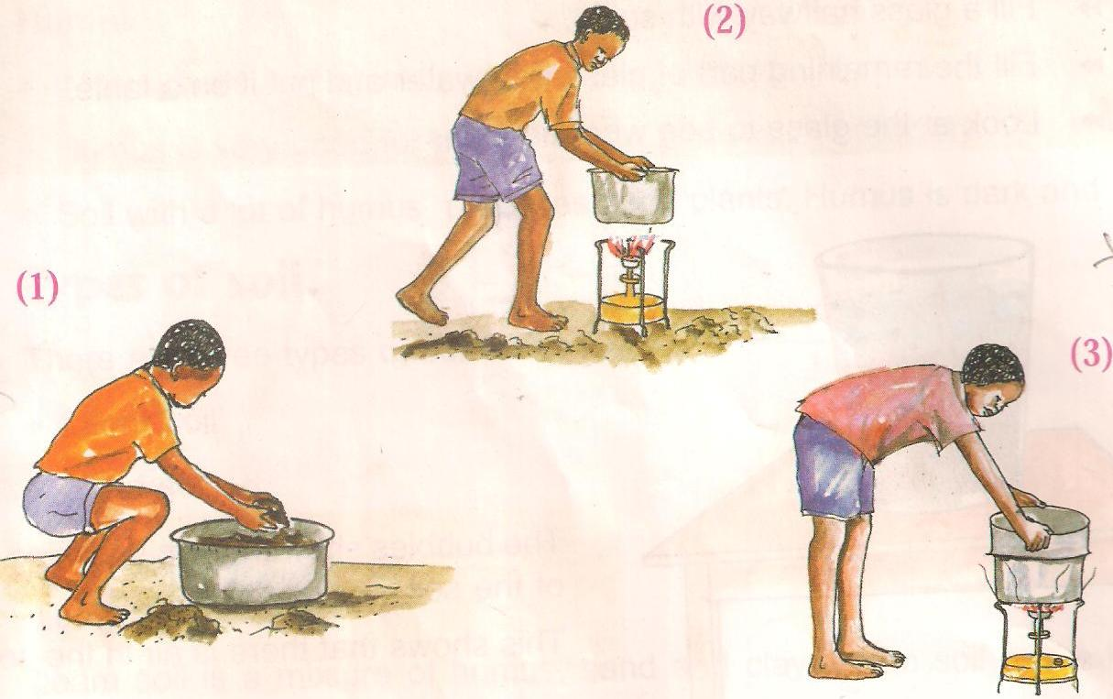

**What do you observe?**

**Water** droplets on cover come from water escaping from the soil in form of water vapour.

**Conclusion**

This shows that soil contains water.

Question: What is does the experiment above show?

**EXPERIMENT TO SHOW THAT SOIL CONTAINS AIR**

* Fill a glass with half dry soil lump.
* Fill the remaining part with water and put it on a table.
* Look at the glass to see what happens.

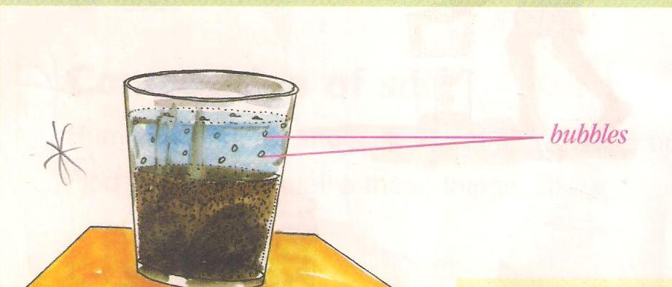

**Observation**

Bubbles are seen coming out of the soil.

**Conclusion**

Bubbles show air escaping from the soil.

Uses air in the soil.

* Helps living things in the soil to breathe
* Helps seeds to germinate

**EXPERIMENT TO SHOW THAT SOIL CONTAINS HUMUS**

* Get a big glass.
* Get some soil and put it in the glass.
* Add water to the glass.
* Now cover the glass, shake it and put it on a table.

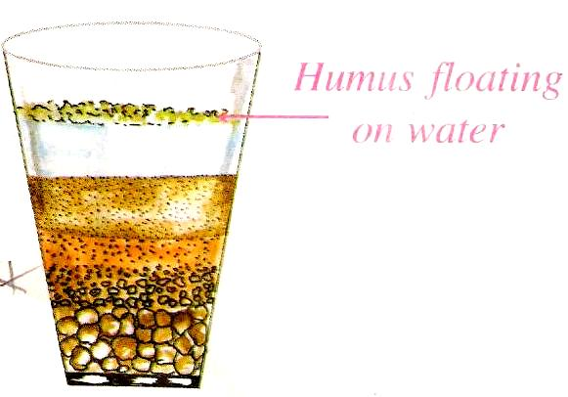

**Observation**

Black substances float on top of water.

Sand and gravel settle at the bottom.

**Conclusion**

The floating substance represents humus.

**How is humus formed?**

* When plants and animals die, they rot and form humus.

**How useful is humus**.

* Humus is very good food for proper growth of plants.
* Humus is dark and soft.

**Types of soil**

* Loam soil
* Sand soil
* Clay soil

**Soil texture**

This is the smoothness or roughness of soil

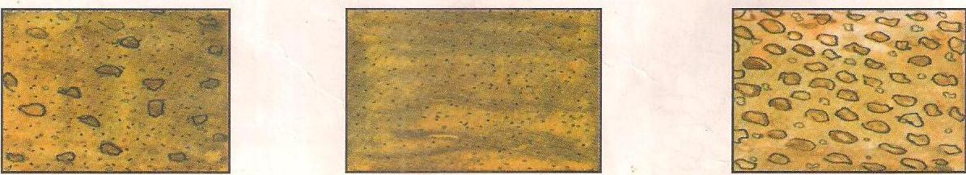

Loam soil clay soil sand soil

Questions.

Mention three types of soil.

Which soil has got the biggest particles?

Name the soil that has got the finest particles.

**Characteristics of loam soil**

* Loam soil is a mixture of humus, sand and clay.
* It has medium – sized particles.
* It has good drainage that is, it holds enough water for the crops to use and grow well.
* It contains a lot of humus.
* It is properly aerated.

Questions

1. Name three components of loam soil.
2. Why is loam soil the best for crop growing?
3. Give one use of loam soil to people.

**Characteristics of sand soil**

* Has the biggest soil particles
* It is loose, light and easy to dig.
* It contains a lot of air.
* It allows water to pass through it easily.
* It has less humus, so it’s not fertile.
* It has the highest rate of drainage i.e. it dries quickly in hot weather.

**Uses of sand soil**

* For building houses
* For making blocks
* For making glasses
* For making sand paper

Questions

1. Why is sand soil not fertile?
2. Which type of soil allows water to pass through it easily?
3. Give two uses of sand soil to people.

**Characteristics of clay soil**

* It has the finest particles.
* It does not allow water through it easily.
* It is the best soil for pottery.
* It is poorly aerated.
* It is not good for plant growth because it water logs.

Uses of clay soil

* For pottery
* For making bricks
* For making tiles

Questions

1. Name the best soil for pottery.
2. Why is clay soil not good for plant growth?
3. Give two uses of clay soil.
4. Name two things at home that are made from clay.

**Soil profile**

* Soil profile is the vertical arrangement of soil layers.
* It is the arrangement of soil from top to bottom layers

**Layers of soil**

Top soil

Sub-soil

Gravel

Parent rock

**Diagram of a soil profile**

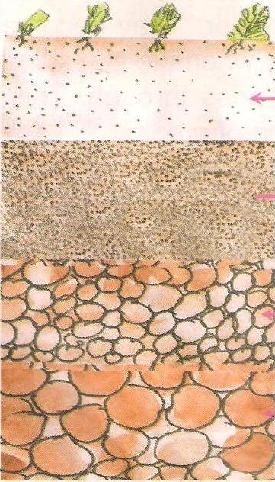

**Top Soil**

**Subsoil**

**Sub-soil**

**Gravel**

**Parent rock**

**Parent rock**

Questions

1. Define soil profile.
2. Name three layers of soil.
3. What is the top most layer of the soil profile?
4. Which layer of the soil supports plant growth?

Top soil

* It is the best layer for plant growth.
* It has a lot of humus.
* It is dark in colour.
* It is a layer where living organism live.

Sub soil

* It is not a good layer for plant growth because it has no humus.
* It is a thick light brown layer.
* There are no living things.

Questions

What is the second layer of the soil profile?

Why is sub soil not a good layer for plant growth?

Why is top soil the best layer for plant growth?

Parent rock

* It’s a rock from which soil is formed.
* Has channels of water running through one rock another.
* The process by which rock breaks to form soil is called weathering.

**Animals that live in soil:**

* Moles
* Worms
* Termites
* Squirrels
* Bacteria

Questions

What is the bottom layer of the soil profile?

What is weathering?

List down any four animals that live in the soil.

**Soil erosion:**

This is the washing away of top soil by its agents

**Agents of soil erosion**

* Running water.
* Strong wind.
* Animals.

**Causes of soil erosion**

* Over grazing.
* Cutting down trees (deforestation).
* Bush burning.
* Mono cropping.
* Drought.
* Over stocking
* Over cultivation

Questions

What is soil erosion?

Name the agents of soil erosion.

Give four causes of soil erosion.

**Control of soil erosion**

1. By mulching –this is the covering of top soil with dry plant materials.
2. By terracing – this is the digging of terraces in the gardens in gardens in hilly areas.

3) Contour ploughing.

4) Planting trees.

5) Planting grass on bare land.

6) Crop rotation.

7) Re-afforestation – planting of trees where they were cut down.

Questions

1. Mention tree ways of controlling soil erosion.
2. How farmers in mountainous areas control soil erosion?
3. What is re-afforestation?

**Mulching**

Mulching- is the covering of top soil with dry plant materials.

**Examples of mulches**

* Dry grass
* Banana leaves
* Coffee husks etc

Advantages of mulching:

* It keeps water in soil.
* It rots to form manure.
* Mulching prevents direct contact of top soil with strong winds / storms

Disadvantages of mulching

* It hides crop pests.
* Mulches are fire hazards.
* It is time consuming to lay mulches.

Questions

1. What is mulching?
2. Name three types of mulches.
3. Why do farmers mulch their gardens? Give two reasons.
4. Mention one disadvantage of mulching.

Effects of soil erosion:

* It causes desertification.
* It leads to famine.
* It leads to soil exhaustion.
* It creates unnecessary gulleys.

What is soil exhaustion?

Soil exhaustion is the loss of soil fertility.

**Causes of soil exhaustion**

* Over cultivation
* Over grazing
* leaching
* Bush burning

How to control soil exhaustion

-By mulching

-Use of crop rotation

-Addition of manure

-Use of fertilizers

Questions

1. Give two effects of soil erosion.
2. What is soil exhaustion?
3. State the causes of soil exhaustion.
4. Mention ways of controlling soil exhaustion.
5. Give two ways of controlling soil erosion.

.

**Crop rotation**

This is the growing of different crops on the same piece of land seasonally.

**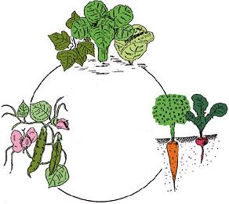**

**Advantages of crop rotation**

* Controls soil erosion
* Improves on soil fertility
* Controls crop pests and diseases.

TOPICAL QUESTIONS

1) Give the three types of soil.

I \_\_\_\_\_\_\_\_\_\_\_\_\_\_\_\_\_\_\_\_\_\_\_\_\_\_\_\_\_\_\_\_\_\_\_\_\_\_\_\_\_\_\_\_\_\_\_\_\_\_\_\_\_\_\_\_\_\_\_

Ii \_\_\_\_\_\_\_\_\_\_\_\_\_\_\_\_\_\_\_\_\_\_\_\_\_\_\_\_\_\_\_\_\_\_\_\_\_\_\_\_\_\_\_\_\_\_\_\_\_\_\_\_\_\_\_\_\_\_\_

Iii \_\_\_\_\_\_\_\_\_\_\_\_\_\_\_\_\_\_\_\_\_\_\_\_\_\_\_\_\_\_\_\_\_\_\_\_\_\_\_\_\_\_\_\_\_\_\_\_\_\_\_\_\_\_\_\_\_\_

2) Write two components of soil from the list below:-

Water, soup, humus, cars living organisms, rock particles

I \_\_\_\_\_\_\_\_\_\_\_\_\_\_\_\_\_\_\_\_\_\_\_\_\_\_\_\_\_\_\_ II \_\_\_\_\_\_\_\_\_\_\_\_\_\_\_\_\_\_\_\_\_\_\_\_\_\_\_\_\_\_\_\_

III \_\_\_\_\_\_\_\_\_\_\_\_\_\_\_\_\_\_\_\_\_\_\_\_\_\_\_\_\_\_ IV \_\_\_\_\_\_\_\_\_\_\_\_\_\_\_\_\_\_\_\_\_\_\_\_\_\_\_\_\_\_\_\_\_

3) Show the four layers of soil on the diagram below



4) Collect a lump of soil put it into a sauce pan

Heat the soil with a metallic cover on top of the sauce pan

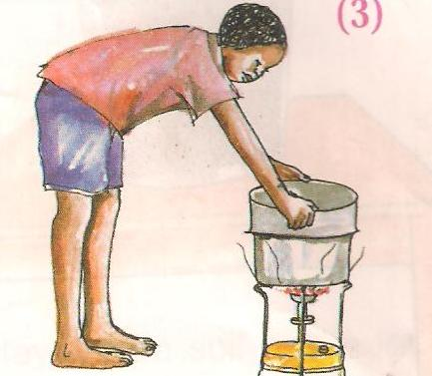 After some time, remove the cover

1. What do you see on the cover?

\_\_\_\_\_\_\_\_\_\_\_\_\_\_\_\_\_\_\_\_\_\_\_\_\_\_\_\_\_\_\_\_\_\_\_\_\_\_\_\_\_\_\_\_\_\_\_\_\_\_\_\_\_\_\_\_\_\_\_\_\_\_\_\_

1. What does this activity show?

\_\_\_\_\_\_\_\_\_\_\_\_\_\_\_\_\_\_\_\_\_\_\_\_\_\_\_\_\_\_\_\_\_\_\_\_\_\_\_\_\_\_\_\_\_\_\_\_\_\_\_\_\_\_\_\_\_\_\_\_\_\_\_\_

5) Get dry soil, water and put the two in a glass

1. What do you see?

\_\_\_\_\_\_\_\_\_\_\_\_\_\_\_\_\_\_\_\_\_\_\_\_\_\_\_\_\_\_\_\_\_\_\_\_\_\_\_\_\_\_\_\_\_\_\_\_\_\_\_\_\_\_\_\_\_\_\_\_\_\_\_\_

1. What does this activity show?

\_\_\_\_\_\_\_\_\_\_\_\_\_\_\_\_\_\_\_\_\_\_\_\_\_\_\_\_\_\_\_\_\_\_\_\_\_\_\_\_\_\_\_\_\_\_\_\_\_\_\_\_\_\_\_\_\_\_\_\_\_\_\_\_

6) Which layer of soil is good for plants to grow? \_\_\_\_\_\_\_\_\_\_\_\_\_\_\_\_\_\_\_\_\_\_\_\_\_\_\_\_\_\_\_\_\_\_\_\_\_\_\_\_\_\_\_\_\_\_\_\_\_\_\_\_\_\_\_\_\_\_\_\_\_\_\_\_\_\_

\_\_\_\_\_\_\_\_\_\_\_\_\_\_\_\_\_\_\_\_\_\_\_\_\_\_\_\_\_\_\_\_\_\_\_\_\_\_\_\_\_\_\_\_\_\_\_\_\_\_\_\_\_\_\_\_\_\_\_\_\_\_\_

Write short sentences about how people use soil as shown in the diagram below

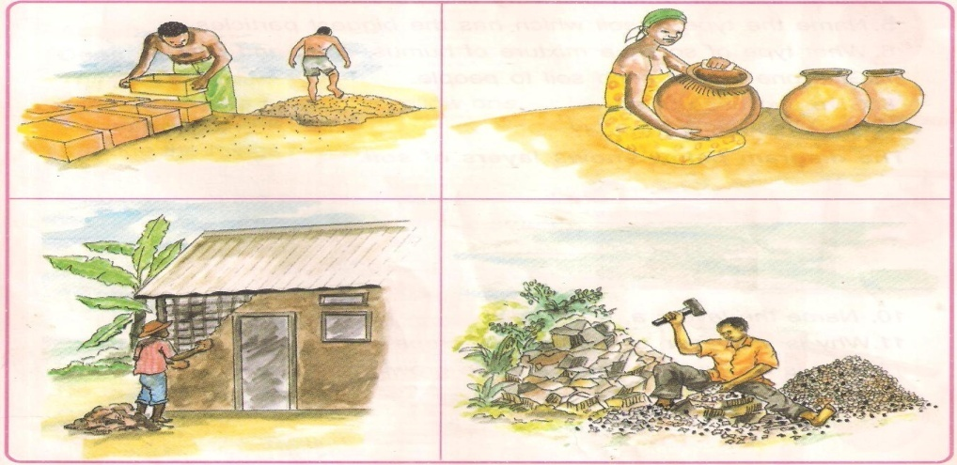

**CHANGES IN OUR ENVIRONMENT**

**Natural changes**

Natural changes are changes brought about by nature and non -living things

Examples of natural changes in our environment.

* Earthquakes
* hailstones
* floods
* storms
* drought
* lightening
* landslides
* thunder

**Natural changes in the sky**

* The sun rises in the East and sets in the West
* The sun is seen in the sky at day time and sets in the evening
* Wind blows from different directions
* Clouds appear in the sky
* The moon appears at night
* Floods are brought in by heavy rains

**Effects of natural changes in our environment**

* Hunger
* Soil erosion
* Migration ie the movement of people from one place to another.
* Diseases/ epidemics
* Destruction of homes and property
* Death

**ACTIVITY**

1)What are natural changes?

2)Mention natural changes in the environment**.**

3)Give three natural changes in the sky.

4)In which direction does the sun rise from?

6)At what time of the day does the moon appear in the sky?

WEEK FIVE

**Lesson one**

**People-made changes**

* These are changes brought about by man in our environment
* Examples
* Building homes
* Building houses
* Planting trees
* Making bridges
* Cutting down trees -deforestation
* Draining swamps
* Disposing wastes
* Burning bricks
* Making medicine from plants

Effects of people-made changes

Soil erosion

Easy transport

Accidents

Drought

Soil exhaustion

Death of animals

Spread of diseases

Desertification

Destruction of anima habitats

**ACTIVITY**

1)What are people-made changes?

2)Give four people-made changes in the environment.

3)Define deforestation?

**Lesson two**

**Ways of managing changes.**

1. Floods
2. Dig big trenches to avoid floods
3. Avoid cleaning swamps because they trap running water.
4. Drought
5. Plant trees
6. Avoid clearing wet lands
7. Dig valley dams
8. Use irrigation method
9. Avoid burning bushes
10. Proper farming methods e.g crop rotation, terracing, mulching.
11. Covering gullies with stones.
12. Educating people about dangers of cutting trees
13. Avoid throwing things that don’t rot e.g plastic.

**ACTIVITY**

1)Give one way of managing floods in our environment.

2)Give two ways of managing drought.

3)Give any two proper farming methods.

**Lesson Three**

**Simple project on tree planting.**

**Lesson four**

**Ways of managing changes continued**

1. Spoilt roads
2. Repair the roads
3. Putting appropriate road signs to warn road users of any road damages
4. Road signs

**PHOTO COPY OF ROAD SIGNS**

**ACTIVITY**

1)How can we manage spoilt roads in our environment?Give two ways.

2)Draw and name three road signs.

**Lesson five**

1. Rusting of machines

Rusting, conditions for rusting and prevention

Rusting is a reddish coating that appears on metals.

-Conditions for rusting

a)Oxgyen

b)moisture

Methods of preventing rusting

a)By oiling

b)By painting

c)By greasing

1. Keep tools in a cool dry place
2. Painting tools like wheel barrow and watering cans

**ACTIVITY**

1)Define rusting.

2)Give two conditions necessary for rusting.

3)Mention two methods of preventing rusting.

**Lesson six**

Accidents

1. Causes of accidents

**An** accident is a sudden happening that causes injury or death.

**Causes of accidents**

**-Ov**er speeding

**-O**ver loading

-Slipperly roads

-Drunken drivers

-Vehicles in poor mechanical co ndition

-Careless pedestrians and cyclists

-Driving after taking drugs

-Over taking at wrong places

**Control of accidents**

1. Keep, ride and walk carefully on the roads
2. Follow traffic rules
3. Use road signs
4. Avoid over speeding
5. Avoid over loading

**ACTIVITY**

1)What is an accident?

2)Give three causes of accidents.

3)Give two ways of controlling accidents on the road.

**Lesson seven**

**En vironment and weather in our division/ subcounty**

**Air and the sun**

1. **Air**

* Air is a mixture of gases
* Moving air is called wind

**Components of air**

* Nitrogen 78%
* Oxygen 21%
* Rare gases 0.97 % (1%)
* Carbon dioxide 0.03% (0.04%)

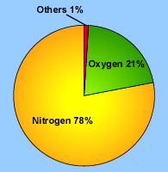

**ACTIVITY**

1)How do we call the mixture of gases?

2)Give two components of air.

3)What is the percentage of nitrogen in the atmosphere?

WEEK SIX

**Lesson one**

**Properties of air**

* Air has weight
* Air occupies space (has volume)
* Air can move things
* Air expands when heated
* Air can be compressed

**Air has weight**

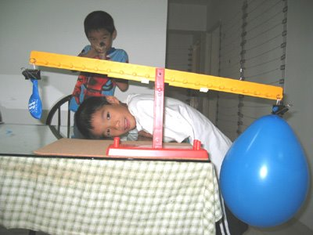

**ACTIVITY**

1)Mention three properties of air.

2)Which property of air is shown above?

3)Which balloon appears on the lower side?

4)Draw the above property of air.

**Lesson two**

**Air occupies space**

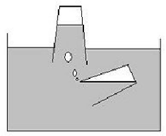

**ACTIVITY**

1)What is the experiment about?

2)What do air bubbles show?

3)Draw the above property of air**.**

**Lesson three**

**Air exerts pressure**

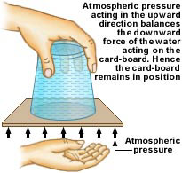

**ACTIVITY**

**1)**What is the experiment about**?**

**2)**Why did n’t the water come out of the glass?

3)Draw the above property of air.

**Lesson four**

**Air expands when heated**

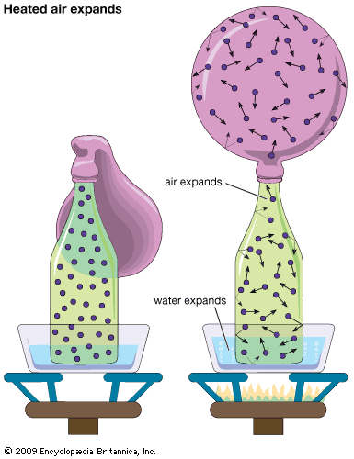

ACTIVITY

1)What is the experiment about?

2)What did you see before heating?

3)Draw the above property of air.

**Lesson five**

**Air can be compressed**

http://ncsgraphicsfionac.files.wordpress.com/2011/09/tension.jpg

**ACTIVITY**

**1)**What is the experiment about?

2)Which property of air is used to inflate car tyres?

3)Draw and name three objects to show that air can be compressed.

**Lesson six**

**Importance/uses of air**

* Air supports burning (oxygen.
* Air is used for transport (Aeroplanes).
* Wind is a source of power to drive wind mills.
* Air is used in germination (oxygen).
* Carbon dioxide is used to preserve drinks.
* Air is used in winnowing seeds.
* Butane gas is used in gas cookers.
* Air is used by birds to fly.
* Wind helps in crop pollination.
* Wind helps in seed dispersal
* Animals breathe in air.
* Moving air helps to cool our bodies.
* Wind sails boats/ships/paper kites.
* Carbondioxide is used in fire extinguishers
* Wind is used for flying kites

**Places where we find fire extinguishers**

* Petrol stations
* Schools
* Hospitals
* Banks
* Hotels

* Homes
* Cars

**ACTIVITY**

1)Name the type of air used in preserving food.

2)Which type of air supports burning?

3)Give three uses of air.

4)Name the gas used in fire extinguishers.

5)Mention 4 places where we find fire extinguishers.

**Lesson seven**

**Dangers of strong winds**

* Strong wind carries away top soil.
* strong winds break boats/ ships on water (destroy property)

(They break down crops and house).

* Wind spreads diseases e.g flu, measles mumps/tubercnlosis etc.
* Wind raises dust, spoiling our eyes and environment as well.
* Strong wind blow off people’s houses
* Strong winds can capsize boats

**ACTIVITY**

1)What do we call moving air?

2)Mention two diseases spread by air.

3)Give three dangers of wind to people.

**WEEK SEVEN**

**Lesson one  
  
b)The sun**

* Biggest star.
* Hottest star.
* It rises from the east every morning.
* The sun sets in the west every evening.
* The sun produces a lot of heat.
* It also produces light

**Uses of the sun (importance of the sun)**

* The sun provides heat.
* The sun provided light.
* The sun’s heart dries clothes/seeds.
* It is a source of solar energy.
* Sunlight is used during photosynthesis.
* The sun helps in formation of rainfall.
* The sun helps living things to grow.
* The sun helps our bodies to make vitamin D

**Lesson two**

**Dangers of the sun**

* Too much sunshine dries crops in the garden.
* Too much sunshine dries water bodies.
* Too much sunshine leads to drought.
* Sunny weather makes animals thirsty.
* Strong sunshine has rays which can cause skin cancer.
* The sun spoils our eyes if you look at it directly.

ACTIVITY

1)Name the hottest star.

2)Where does the sunrise from?

3)Name the type of vitamin we get from the sun?

4)Name the source of energy got from the sun.

5)Give two uses of sun.

**Lesson three**

* **Shadows and opaque objects**

**What is a shadow?**

A shadow is a dark shape formed when light is blocked by an opaque object.

**What is an opaque object?**

**A**n opaque object is an object that does not allow light to pass through.

* Shadows are longer in the morning and evening.
* Shadows are shorter at mid-day and noon.

**Importance of shadows in our environment**

* Tells time
* Gives us shade

A shadow in the morning

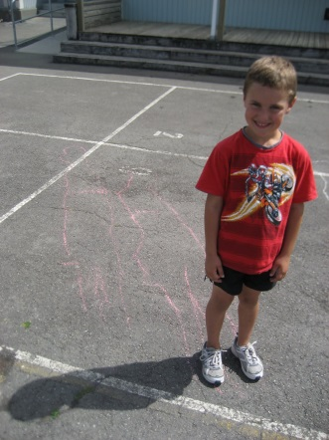

A shadow at noon

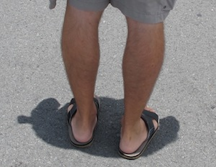

A shadow in the evening

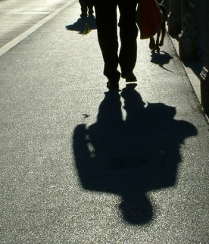

ACTIVITY

1)What is a shadow?

2)What are opaque objects?

3)Give one use of shadows to people.

4)When is the shadow of an object shorter?

**Lesson four**

**TOPICAL QUESTIONS**

1)Draw and name any three properties of air.

2)Which part of air supports burning?

3)Why is carbondioxide used to put out fire?

4)Where will a shadow of a person be when the sun is in the west?

5)Name two things that can be moved by air.

6)Give two dangers of wind.

7)Give two uses of sun to

a)people

b)plants

8)Where does the sun rise from?

9)What causes day and night?

10)Name two types of clouds.

11)What do we call dark clouds that bring rain?

12)What is the main natural source of water?

**Lessen five**

**WATER**

1. **How rain is formed:**

**Water/rain cycle**

**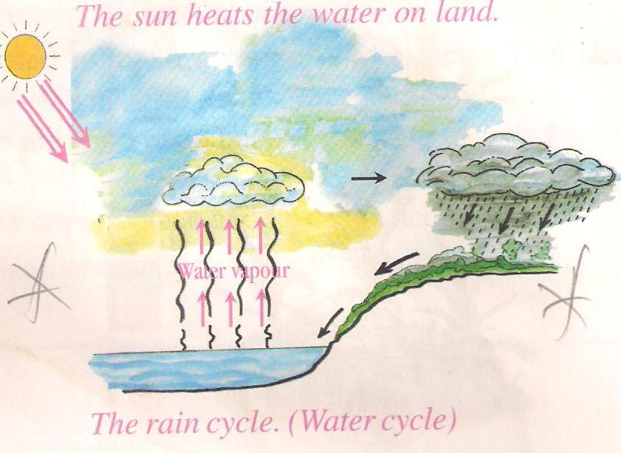**

The sun **heats** the water body

Water **evaporates** to form water vapour

Water vapour rises and **condenses** to form nimbus clouds

Clouds become heavy, lower down and **melt** to form rainfall

ACTIVITY

1)What is the use of sun in the rain cycle?

2)Which clouds give us rain?

3)Name the processes that take place in the rain cycle.

4)In four sentences, explain how rain is formed.

**Lesson six**

**RAIN ( Formation of raindrops)**

Rain is the main natural source of water.

Rain is formed from clouds.

**Importance of rain**

* Rain provides water for drinking.
* For washing.
* For watering plants.
* For softening soil to ease plant growth.
* Rainfall washes away dust from air
* It cools down temperature.
* It reduces dust on murram roads.

watering plants

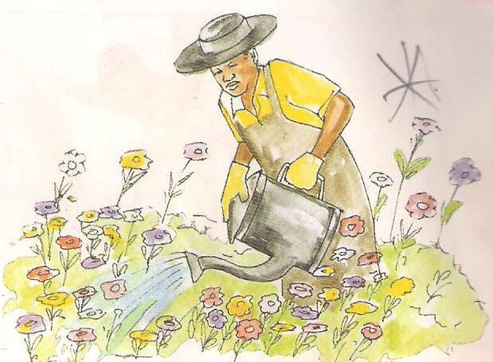

Water for drinking

**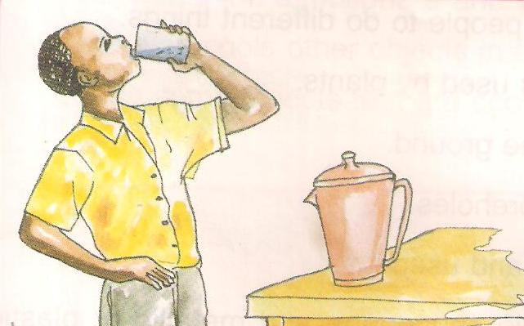**

ACTIVITY

1) Identify the main natural source of water

2)Give four uses of rain to plants and animals.

3)In which season do farmers plant their crops?

.

**Lesson seven**

**Dangers of heavy rainfall**

* Leads to soil erosion.
* Lightning can strike people and other animals.
* It breaks down houses and crops.
* It leads to floods.
* It makes murram roads mudy

**Solutions to the above problems**

* By practicing better methods of farming
* By putting lightning conductors on the roofs
* Planting trees to act as wind breaks
* To avoid swamp drainage
* Tarmacing roads
* ACTIVITY
* 1)Give three dangers of rain rainfall.
* 2)Mention ways of controlling :
* Soil erosion
* Floods
* \
* -0Lightning

**WEEK EIGHT**

**Lesson one**

**CLOUDS**

There are four types of clouds namely:-

* Nimbus clouds

[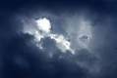](http://i1.trekearth.com/photos/98218/nimbus_clouds.jpg)

* Cirrus clouds
* Stratus clouds
* Cumulus clouds

NOTE PHOTO COPY TYPES OF CLOUDS

Cirrus - are the furthest/highest clouds.

Stratus - clouds are commonly dark grey and sometimes cause drizzles.

Cumulus clouds commonly white in colour.

Cumulo - nimbus clouds – bring rain/storms.

Nimbus clouds - bring steady rainfall.

ACTIVITY

1)Which clouds bring steady rainfall?

2)Name the clouds that cause drizzles.

3)Mention the highest clouds

**Lesson two**

**How clouds affect the environment:**

* Nimbus clouds bring steady rains.
* A cloudy weather brings a low temperature.
* Cumulus clouds bring a clear day

**Dangers of clouds**

* They cause lightning
* They bring heavy rain fall which cause floods
* Clouds cause accidents to people who use air transport.

ACTIVITY

1)Mention two effects of clouds to the environment.

2)Give two dangers of clouds to people.

**.**

**Lesson three**

**How rain is measured**

* A rain gauge is the weather instrument for measuring rain.

**ACTIVITY**

-Name the different parts of a rain gauge.

-Give the functions of the different parts of the rain guage

-Draw and colour a rain gauge.

-Where should a rain gauge be placed?

-Why is a rain gauge important to a farmer?

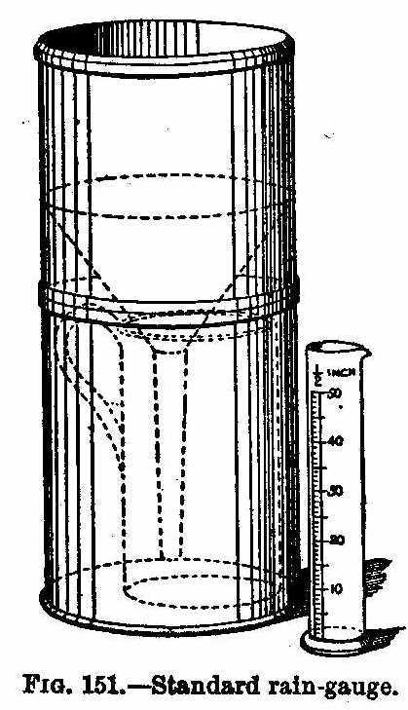

**Lesson four**

**Other natural sources of water**

* Lakes - Streams
* Rives - Oceans

**Artificial sources of water.**

* Bore holes - valley dams
* Ponds - springs

ACTIVITY

1)Name the main natural source of water.

2)Identify two other natural sources of water.

3)Mention two artificial sources of water.

4)Name the instrument used to measure rainfall.

5)Identify two ways of harvesting water.

6)Mention two ways of maintaining water sources.

**Lesson five**

**Managing Water**

1. Importance of water

To people

-For cooking

-For washing clothes

-For drinking

-For washing utensils

To plants

-It helps plants to make their own food

-It helps the seeds to germinate

ACTIVITY

1)Give three importance of water to people

2)Mention two uses of water to plants

**Lesson six**

**.**

**Water harvesting**

Water can be harvested by using

-Tanks

-Buckets

-Basins

-Digging valley dams

-Jerrycans

**Maintainance of water sources**

Repairing the damages

Fencing the water sources

Cleaning water sources

Avoid dumping wastes in water sources

**Lesson seven**

TOPICAL QUESTIONS

1)Name any three types of cloud.

2)Identify the main natural source of water.

3)In which season take place?

4)Name two ways in which people can control floods.

5)Identify two ways of harvesting water.

6)Give two uses of water to plants.

7)Name the instrument used to measure rainfall.

8)Mention three ways of maintaining water sources.